Sujay Kallamadi

IST 210- Lab 01

Due: 9/20/15

|  |  |  |  |  |  |  |  |
| --- | --- | --- | --- | --- | --- | --- | --- |
| **Table Name** | **Attribute Name** | **Contents** | **Type** | **Format** | **Required** | **PK/ FK** | **FK Referenced Table** |
| Course | course_id  call_id  course_name  credits | Course ID  Call ID  Course name  Credits | numeric  varchar(10)  varchar(25)  numeric | 999  Xxxxxxxx  Xxxxxxxx  999 | Y | PK |  |
| Course Section | c_sec_id  course_id  term_id  sec_num  f_id  c_sec_day  c_sec_time_start  c_sec_time_end  loc_id  max_enrl | Course Section ID  Course ID  Term ID  Section #  Faculty ID  Course Section Day  Course Section start time  Course Section end time  Location ID  Maximum enrollment | numeric  numeric  numeric  numeric  numeric  varchar(10)  datetime  datetime  numeric  numeric | 999  999  999  999  999  Xxxxxxxx  yyyy-mm-dd 00:00:00:000  yyyy-mm-dd 00:00:00:000  999  999 | Y  Y  Y  Y  Y | PK  FK  FK  FK  FK  FK | Course  Term  Course Section  Faculty  Location |
| Enrollment | s_id  c_sec_id  grade | Student ID  Course Section ID  Grade | numeric  numeric  char(1) | 999  999  X | Y  Y | PK/FK  PK/FK | Student  Course Section |
| Faculty | f_id  f_last  f_first  f_mi  loc_id  f_phone  f_rank  f_pin | Faculty ID  Faculty last name  Faculty first name  Faculty middle initial  Location ID  Faculty phone #  Faculty ranking  Faculty PIN | numeric  varchar(30)  varchar(30)  char(1)  numeric  varchar(10)  varchar(8)  numeric | 999  Xxxxxxxx  Xxxxxxxx  X  999  Xxxxxxxx  Xxxxxxxx  999 | Y | PK  FK | Location |
| Location | loc_id  bldg_code  room  capacity | Location ID  Building code  Room #  Rm Capacity | numeric  varchar(10)  varchar(6)  numeric | 999  Xxxxxxxx  999  999 | Y | PK |  |
| Student | s_id  s_last  s_fist  s_mi  s_address  s_city  s_state  s_zip  s_phone  s_class  s_dob  s_pin  f_id | Student ID  Student last name  Student first name  Student middle initial  Student address  Student city  Student state  Student zip  Student phone #  Student class  Student DOB  Student PIN  Faculty ID | numeric  varchar(30)  varchar(30)  char(1)  varchar(25)  varchar(20)  char(2)  varchar(10)  varchar(10)  char(2)  datetime  numeric  numeric | 999  Xxxxxxxx  Xxxxxxxx  X  Xxxxxxxx  Xxxxxxxx  XX  Xxxxxxxx  Xxxxxxxx  XX  yyyy-mm-dd 00:00:00:000  999  999 | Y | PK  FK | Faculty |
| Term | term_id  term_desc  status | Term ID  Term Description  Status | numeric  varchar(20)  varchar(20) | 999  Xxxxxxxx  Xxxxxxxx | Y | PK |  |

* I followed the table example in the book, minus Range because there were no specific ranges I found.

2.

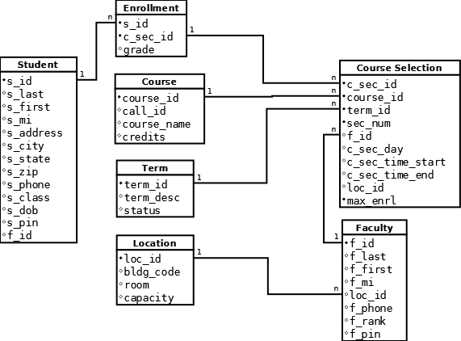

**I used the program called Dia to make this. Don’t mind the descriptions (1, n) for each reference. Also, to signify which are required, a black dot has been placed to the left of each name, instead of an empty circle.

3.

1. Select * from uc_course /* 5 */
2. Select * from uc_course_section where c_sec_id = '2' /* Tuesdays and Thursdays */
3. select * from uc_enrollment /* 8 -- Counted the NULL values */
4. select * from uc_faculty /* rank is ASST - which I believe is Assistant */
5. select * from uc_location where room = '211' /* Max capacity = 55 */
6. select * from uc_student where s_state = 'ME' /* 6 records are shown for students belonging to Maine */
7. select * from uc_term where status = 'open' /* 1 */

Results: (Will be easier to read on Notepad)

course_id call_id course_name credits

--------------------------------------- ---------- ------------------------- ---------------------------------------

1 MIS 101 Intro. to Info. Systems 3

2 MIS 301 Systems Analysis 3

3 MIS 441 Database Management 3

4 CS 155 Programming in C++ 3

5 MIS 451 Web-Based Systems 3

(5 row(s) affected)

c_sec_id course_id term_id sec_num f_id c_sec_day c_sec_time_start c_sec_time_end loc_id max_enrl

--------------------------------------- --------------------------------------- --------------------------------------- --------------------------------------- --------------------------------------- ---------- ----------------------- ----------------------- --------------------------------------- ---------------------------------------

2 1 4 2 3 TR 1900-01-01 09:30:00.000 1900-01-01 10:45:00.000 7 35

(1 row(s) affected)

s_id c_sec_id grade

--------------------------------------- --------------------------------------- -----

1 1 A

1 4 A

1 6 B

1 9 B

2 1 C

2 5 B

2 6 A

2 9 B

3 1 C

3 12 NULL

3 13 NULL

4 11 NULL

4 12 NULL

5 1 B

5 5 C

5 9 C

5 11 NULL

5 13 NULL

6 11 NULL

6 12 NULL

(20 row(s) affected)

f_id f_last f_first f_mi loc_id f_phone f_rank f_pin

--------------------------------------- ------------------------------ ------------------------------ ---- --------------------------------------- ---------- -------- ---------------------------------------

1 Cox Kim J 9 7155551234 ASSO 1181

2 Blanchard John R 10 7155559087 FULL 1075

3 Williams Jerry F 12 7155555412 ASST 8531

4 Sheng Laura M 11 7155556409 INST 1690

5 Brown Philip E 13 7155556082 ASSO 9899

(5 row(s) affected)

loc_id bldg_code room capacity

--------------------------------------- ---------- ------ ---------------------------------------

8 BUS 211 55

(1 row(s) affected)

s_id s_last s_first s_mi s_address s_city s_state s_zip s_phone s_class s_dob s_pin f_id

--------------------------------------- ------------------------------ ------------------------------ ---- ------------------------- -------------------- ------- ---------- ---------- ------- ----------------------- --------------------------------------- ---------------------------------------

1 Miller Sarah M 144 Windridge Blvd. Portland ME 04102 2075559876 SR 1985-07-14 00:00:00.000 8891 1

2 Umato Brian D 454 St. John's Place Bath ME 04530 2075552345 SR 1985-08-19 00:00:00.000 1230 1

3 Black Daniel NULL 8921 Circle Drive Port Clyde ME 04332 2075553907 JR 1982-10-10 00:00:00.000 1613 1

4 Mobley Amanda J 1716 Summit St. Augusta ME 04332 2075556902 SO 1986-09-24 00:00:00.000 1841 2

5 Sanchez Ruben R 1780 Samantha Court Rockland ME 04841 2075558899 SO 1986-11-20 00:00:00.000 4420 4

6 Connoly Michael S 1818 Silver Street Bar Harbour ME 04609 2075554944 FR 1986-12-04 00:00:00.000 9188 3

(6 row(s) affected)

term_id term_desc status

--------------------------------------- -------------------- --------------------

6 Summer 2009 OPEN

(1 row(s) affected)